Ice Cube Packing Machine

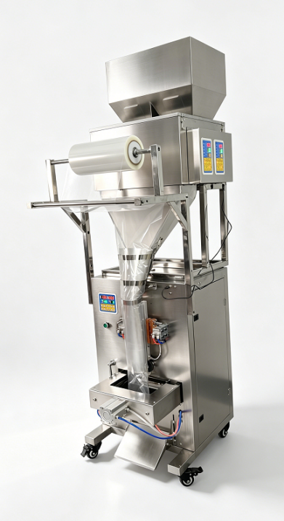
1. Horizontal Screw Feeding System
（1）Anti-sticking design: Special structure prevents ice cubes from sticking together, ensuring smooth and continuous feeding.
（2）Even feeding: Precise screw control ensures consistent ice volume per bag.
（3）No crushed ice: Enlarged screw gap allows gentle conveying, keeping ice cubes intact without breaking.
2. Internal Waterproof Treatment
（1）Wires are protected with conduit tubing to prevent short circuits
（2）Leak-proof sealing
（3）External control panel with waterproof design for enhanced durability
（4）Electroplated surface treatment to prevent rust
Packaging range: 1kg, 2kg, 3kg, 5kg per bag, etc.

Model | Q-2T5000 | Q-2T9999
Packaging range (adjustable) | Max 3kg ice cubes | Max 5kg ice cubes
Speed (bags/min) | 3–10 | 3–8
Film width (cm) | 46–72 | 68–85
Film length (cm) | 1–42 | 1–42
Sealing type | Back seal | Back seal
Power | 1600W | 1600W
Machine dimensions (cm) | 86 × 102 × 258 | 86 × 94 × 268
Price(USD) | 2700 | 2990

If you would like to know the prices of other models, please contact us.

Ice Maker Machine
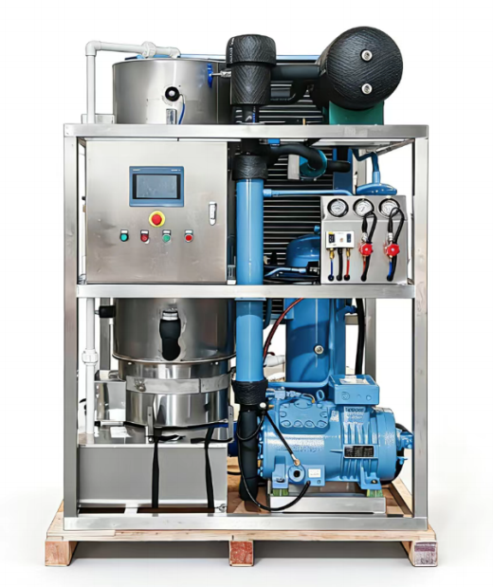
- standard working condition ambient temperature 28 °C. water temperature 23'C.

- evaporating temperature -15℃.

- condensing temperature 40℃

- power supply 3P/380V/50HZ or customized

- tube ice size pp22mm/p29mm/yp35mm.

- refrigerant R404A/R22
Model | GB1T-R4A | GB2T-R4A | GB5T-R4W
Capacity(T/24h) | 1T | 2T | 5T
Refrigerating capacity(KW) | 9.2 | 16.9 | 39
Total power(KW) | 5.1 | 9 | 18.5
Chilled water(KW) | 3.85 | 6.9 | 15.5
Cooling way | Air cooling | Air cooling | Water cooling
Water inlet/drain pipe | 3/4" | 3/4" | 3/4"
Unit dimension(mm) | 1100×1200×2000 | 1400×1400×2000 | 1500×1400×2400
Weight(KG) | 700 | 1100 | 1500
Price(USD) | 7700 | 11800 | 19900
If you would like to know the prices of other models, please contact us. We offer machines with a maximum capacity of up to 20 tons.

Ice Cube Feeding Machine
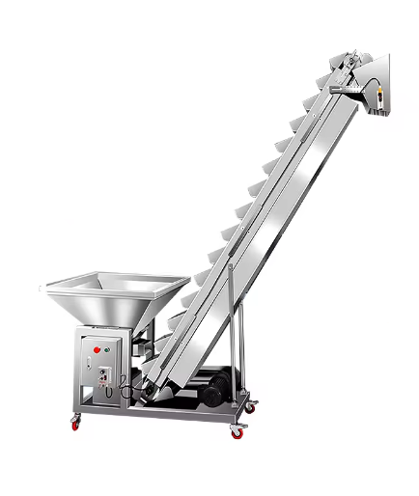

1.Replaces manual feeding to the packaging machine hopper, enabling continuous automatic production and reducing manual intervention.
2.Ensures the packaging machine hopper always has sufficient material, preventing idle operation or shutdown due to material shortage.

Model | TS-240 | Price(USD)
Height from floor | 240cm | 2550
Large hopper dimensions | 84*84*40cm | 2550
Small hopper dimensions | 20*16*15cm | 2550
Number of small hoppers | 30 piece | 2550
Power | 370W | 2550
Adjustable height | 20cm | 2550
Machine dimensions | 240*73*305cm | 2550
If you are interested in our machines, please feel free to contact us:

📱 WhatsApp: +86 13375997863
📧 Email: Abby@jd-packing.com
🌐 Website: https://www.jd-packing.com
🏢 Company Address: Room 502-2, No. 2 Gaoqi South 12th Road, Xiamen Area, China (Fujian) Pilot Free Trade Zone

